**Linux Operating System and Source Code Management with Git-3.0**

**Assignment 1:** Ensure the script checks if a specific file (e.g., myfile.txt) exists in the current directory. If it exists, print "File exists", otherwise print "File not found".

here's a simple shell script that checks if a specific file (e.g., myfile.txt) exists in the current directory:

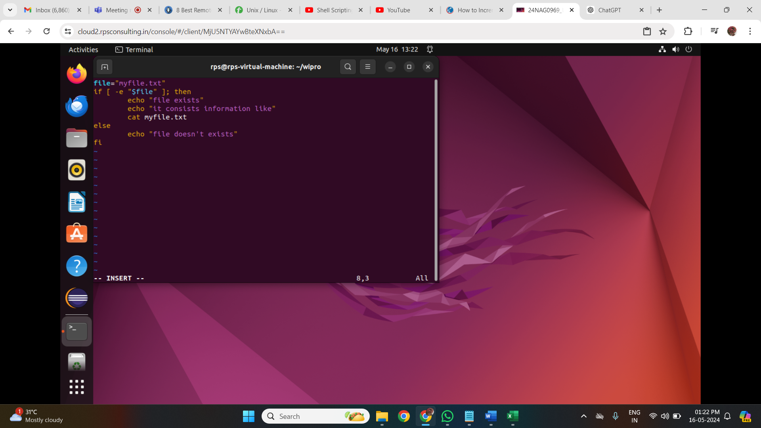

Save this script into a file, for example, **check_file.sh**. Make sure the file has execute permission (**chmod +x check_file.sh**). Then you can run it using **./check_file.sh** in the terminal while being in the directory where you want to check for the file.

**Assignment 2:** Write a script that reads numbers from the user until they enter '0'. The script should also print whether each number is odd or even.

Here's a shell script that reads numbers from the user until they enter '0', and then prints whether each number is odd or even:

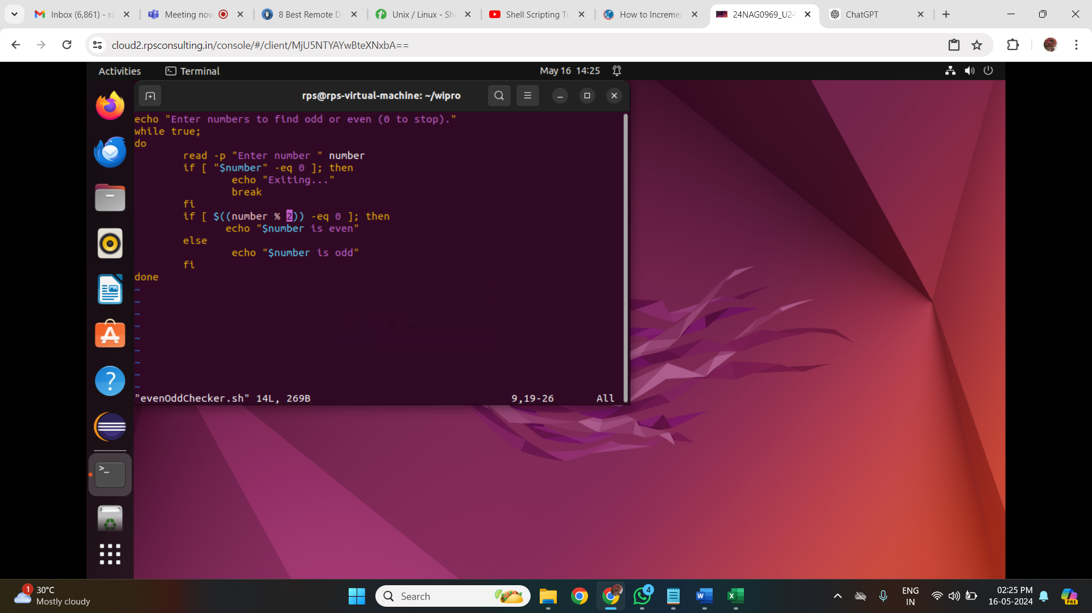

Save this script into a file, for example, **odd_even_checker.sh**. Make sure the file has execute permission (**chmod +x odd_even_checker.sh**). Then you can run it using **./odd_even_checker.sh** in the terminal. It will prompt you to enter numbers until you enter '0', and for each number entered, it will print whether it's odd or even.

Here is the output:

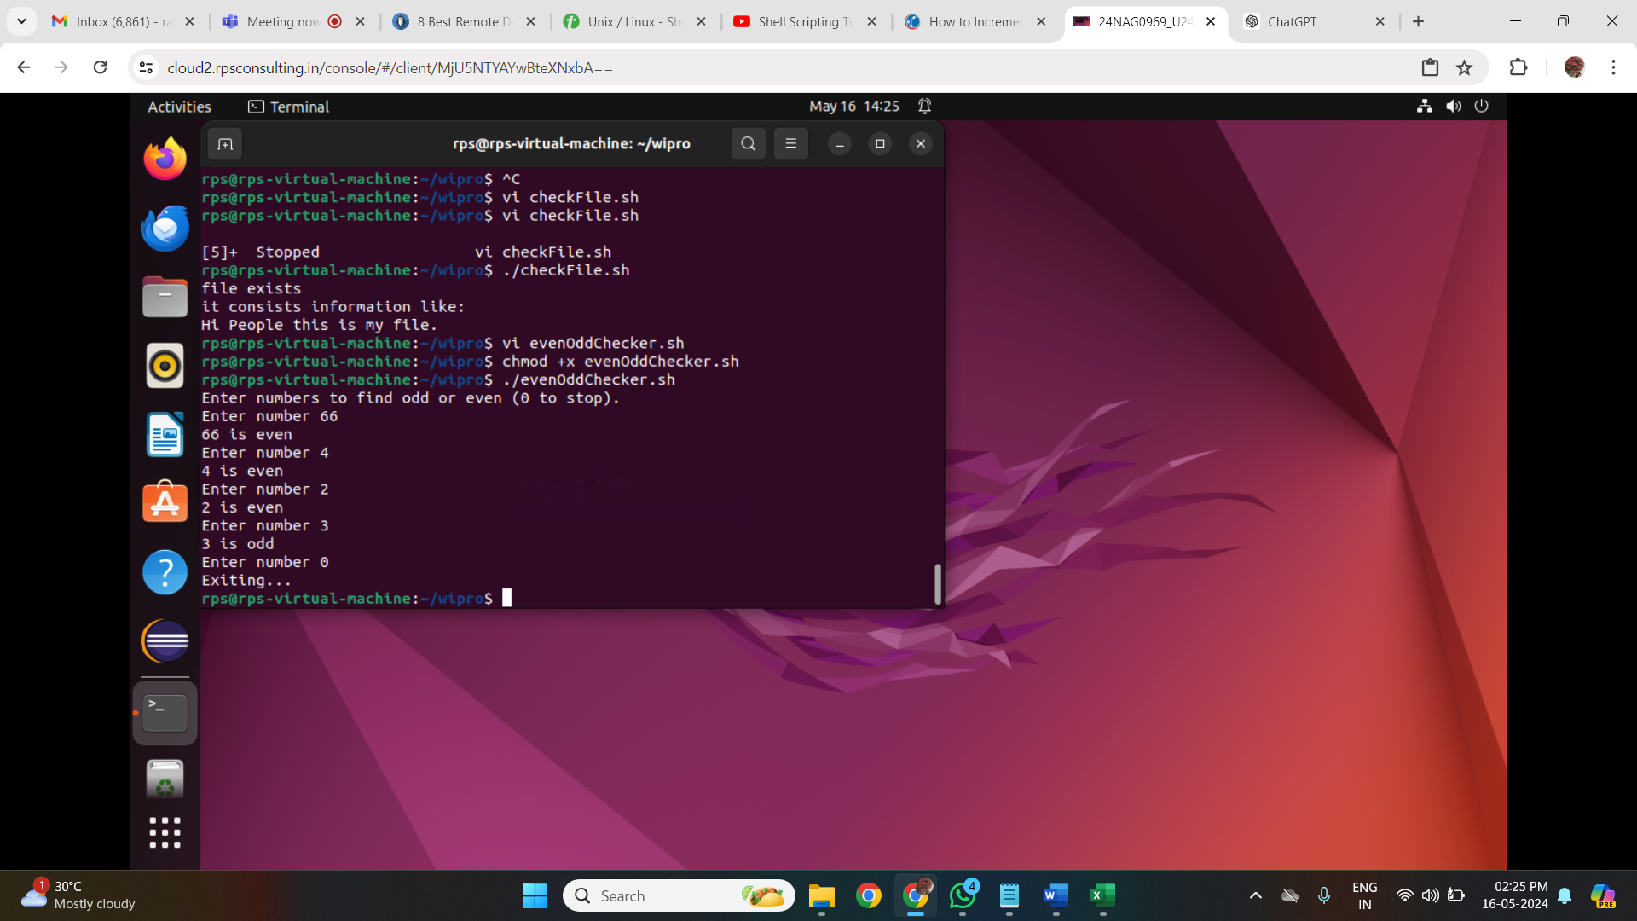

**Assignment 3:** Create a function that takes a filename as an argument and prints the number of lines in the file. Call this function from your script with different filenames.

script with a function that takes a filename as an argument and prints the number of lines in the file:

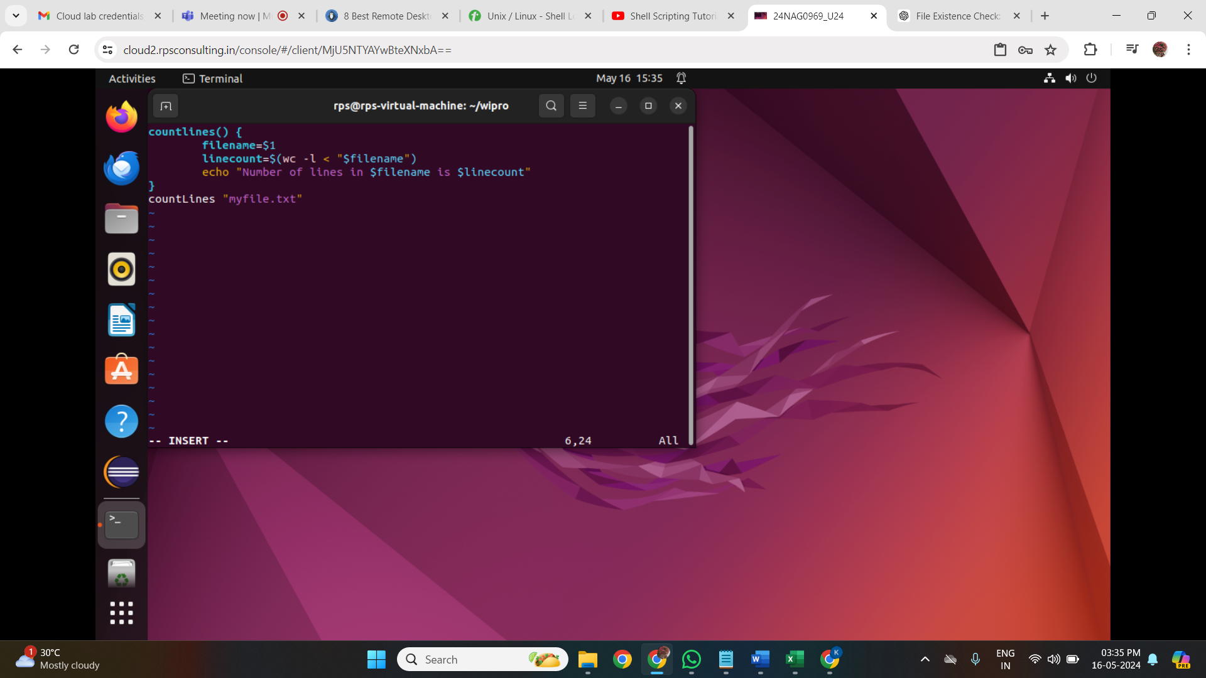

**Assignment 4:** Write a script that creates a directory named TestDir and inside it, creates ten files named File1.txt, File2.txt, ... File10.txt. Each file should contain its filename as its content (e.g., File1.txt contains "File1.txt").

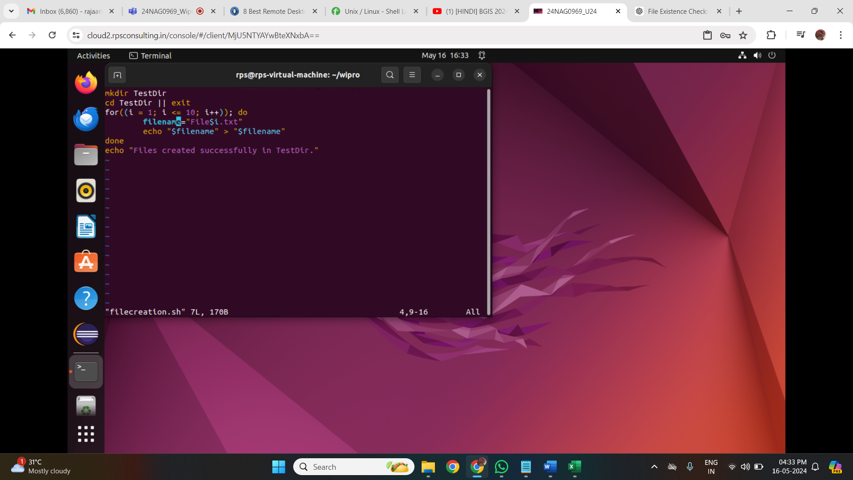

**Assignment 5:** Modify the script to handle errors, such as the directory already existing or lacking permissions to create files.

Add a debugging mode that prints additional information when enabled.

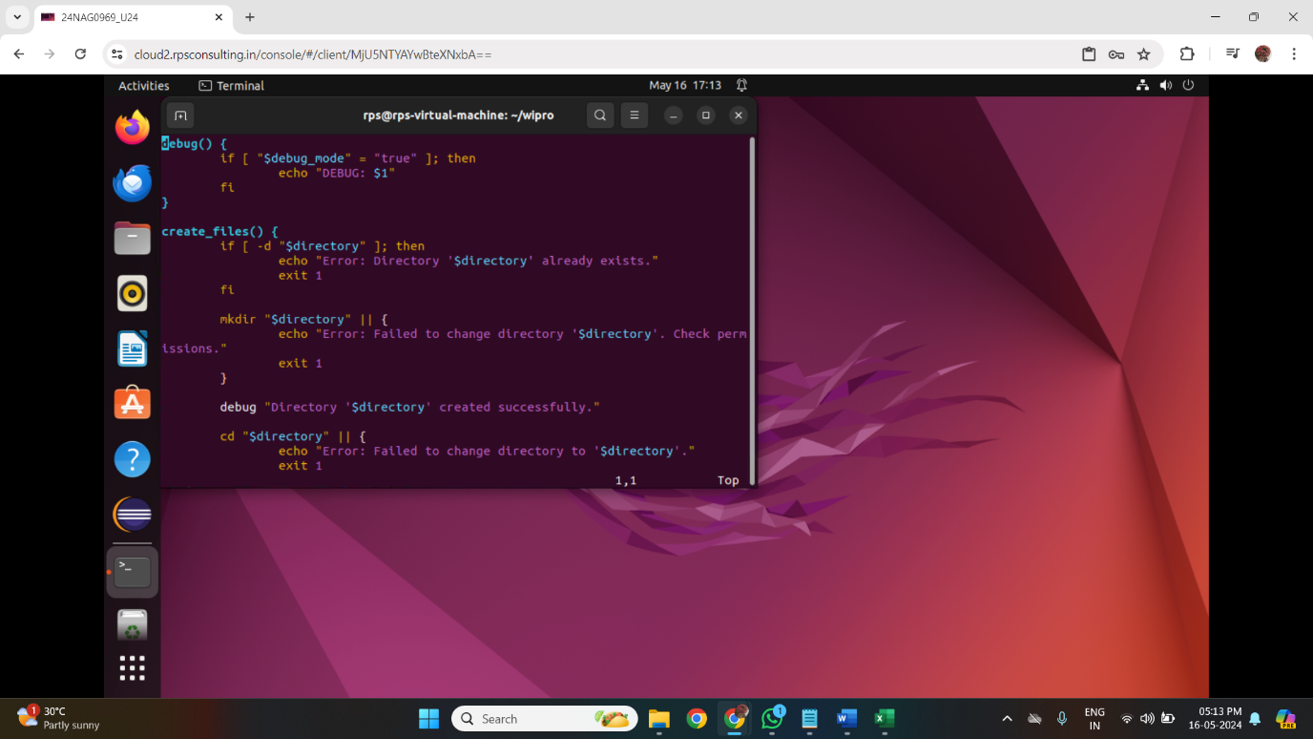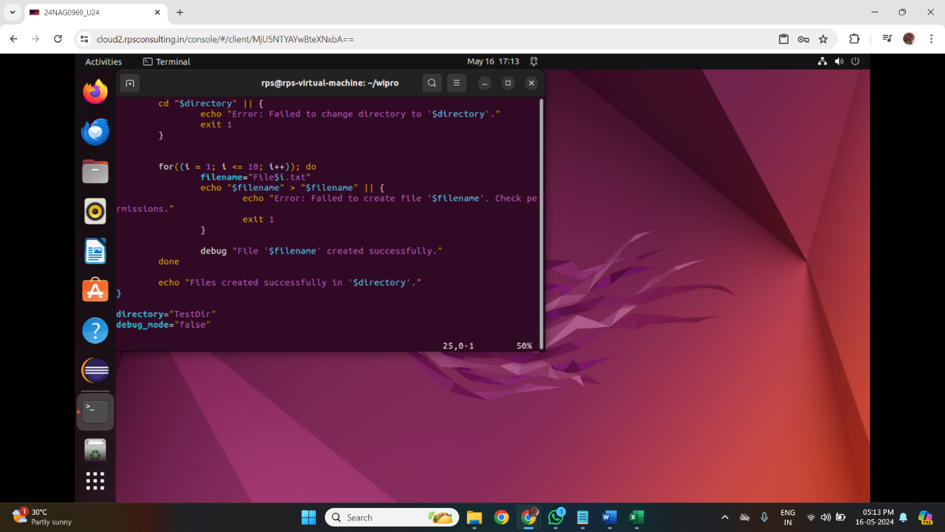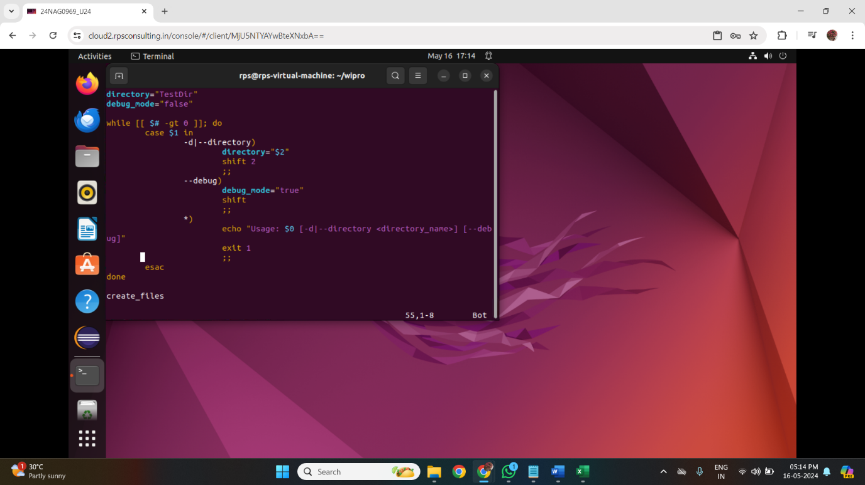

**Assignment 6:** Given a sample log file, write a script using grep to extract all lines containing "ERROR". Use awk to print the date, time, and error message of each extracted line.

Data Processing with sed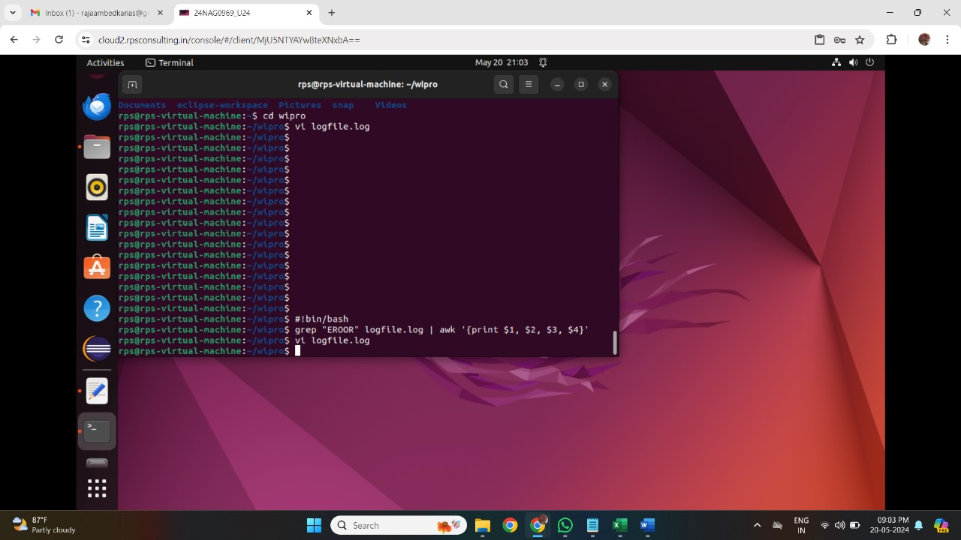

**Assignment 7:** Create a script that takes a text file and replaces all occurrences of "old_text" with "new_text". Use sed to perform this operation and output the result to a new file.

